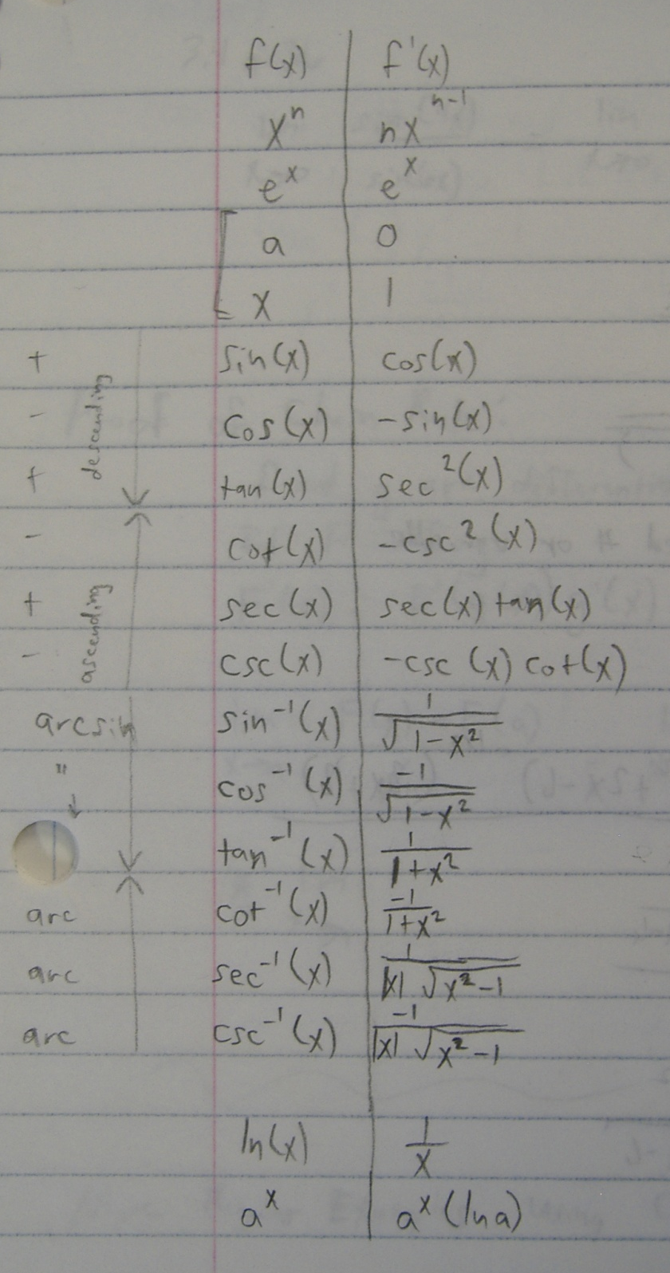
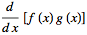
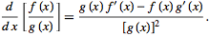
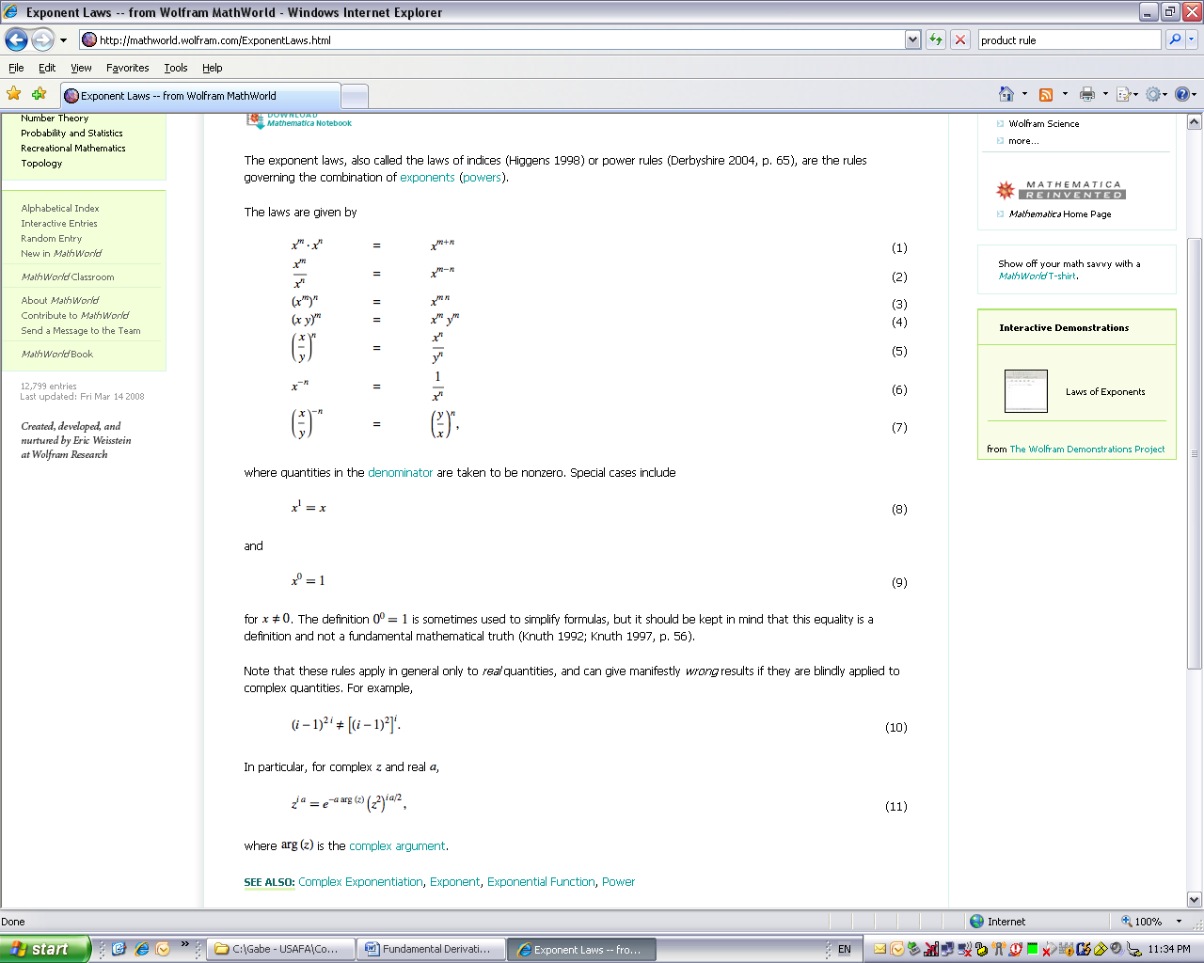
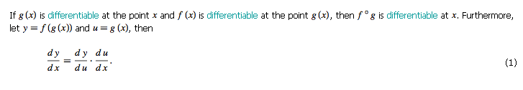
Equation for a Line
Point Slope Form:
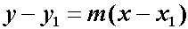

Product Rule:
Quotient Rule:
Exponent Laws:
Ex:
Dot Product:
Pneumonic: “ultraviolet vudu.” Find u using “LogPoET” (choose u in this order: Logarithmic (ex: ln(x)), Polynomial (ex: 2x2+x), Exponential (ex: ex), Trigonometric (ex: sin & cos)). The piece left over is dv. Differentiate u and integrate dv and then plug and chug.
Ex:
Chain Rule:
Integration by Parts:
Chain Rule (“derivative of the outside times the derivative of the inside”):
Integration by Parts Example
(polynomial is higher than exponential, so choose u = x)

→

